Submission to CDSS

Name: shukie

Title: Rhizomatic Ramblings: Art Brut as an approach to representing a PhD thesis.

Dimensions – Canvas 101cm x 81cm x 2cm; Clamps add additional 20cm

Additional notifications. The image will include QR codes and a different stretched rubber than the one shown. There is also the intention to attach a small TV screen showing a movie on a loop. Ideally, I will make this battery operated but it might require a plug socket.

Images (all images show work as it is now. It continues to live and therefore growth is possible)

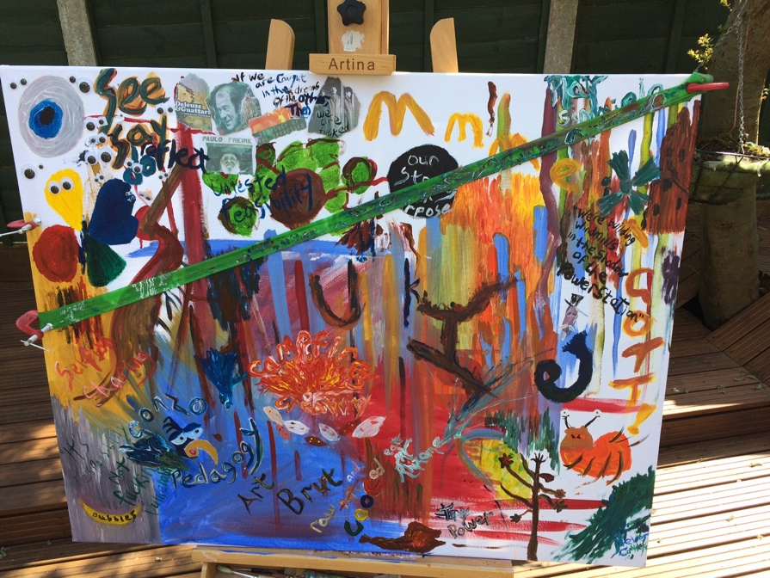

Figure 1: Full image

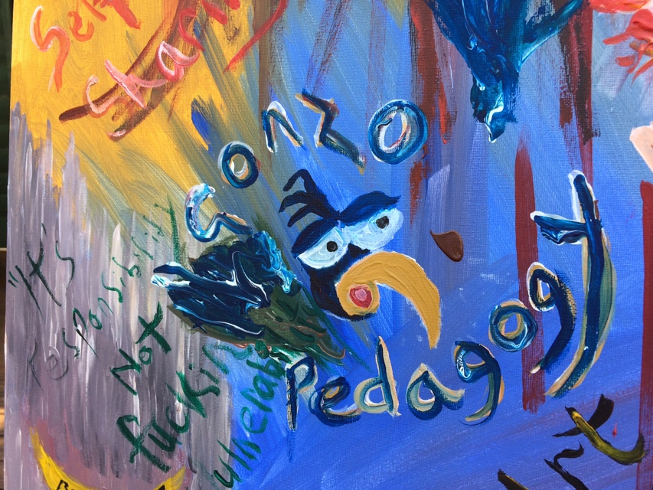

Figure 2: Detail, Gonzo Pedagogy

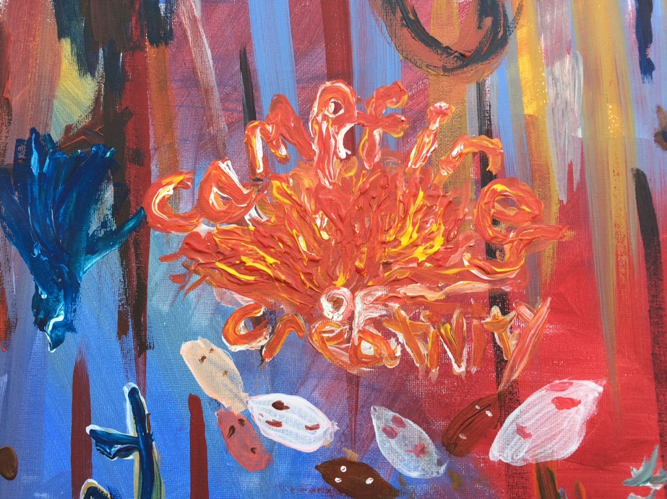

Figure 3: Detail, Campfires of Creativity

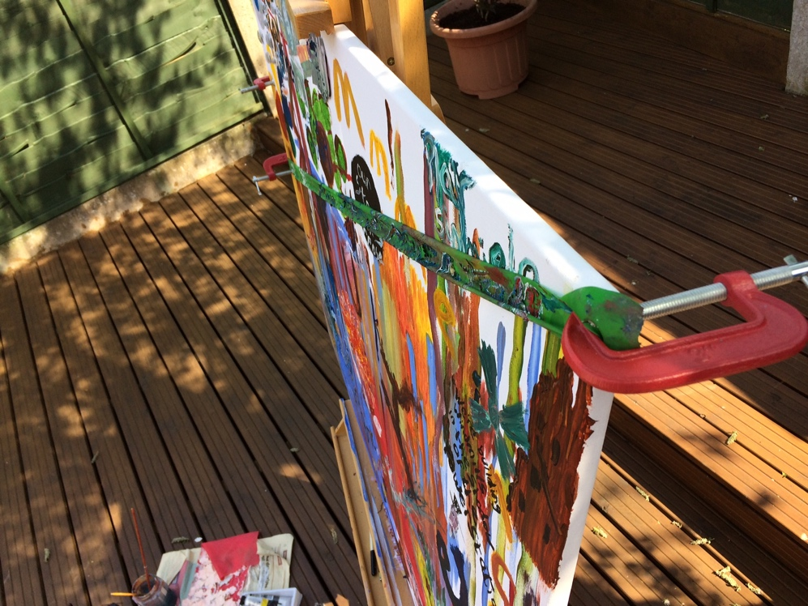

Figure 4: alternate view showing clamps

Abstract

Beginning any project is driven in part by dreams, or perhaps the more diluted term of aspirations. This began with a dream. A thesis which was a lived realisation of space to teach and learn BEYOND and WITHOUT institutions. Both ‘teach’ and ‘learn’ come with enough connotations to highlight that such an endeavour was fraught with difficulty. The very notion of taking on new information comes with a restrictive, normalised concern with teachers, schools, colleges, exams – so normalised that the whole process required a move to deep clean the minds and the expectations of what teaching is, what learning is, deep clean and begin again.
This Deleuzean deterritorialization requires more than the paring back of a single mind, but of collective minds. The theoretical and the emotional, the visceral and the ethereal, the visual and the felt, the cognitive and the critical, all needed new modes of thinking and being and doing. Deleuze led to rhizomes, rhizomes opened up what we know to be true. That the learning we encounter is seldom neat enough to come handily located in colleges and schools, universities or other spaceships of knowing dropped on us from a short height, of this we know. But we agree enough to allow its foul cousins, the pretence of learning, the packaged courses, the artificial definitions of certification and accreditation, to thrive and define us.

My own learning was most inspired by feeling Deleuze was right, because I already knew it, we all do. Deleuze also led to Art Brut. I give this at length because not one word seems superfluous.

Art Brut. We understand by this works by those untouched by artistic culture; in which copying has little part, unlike the art of the intellectuals. Similarly, the artists take everything (subjects, choice of materials, modes of transposition, rhythms, writing styles) from their own inner being, not from the canons of classical or fashionable art. We engage in an artistic enterprise that is completely pure, basic; totally guided in all its phases solely by the creators own impulses. It is therefore, an art which only manifests invention, not the characteristics of cultural art which are those of the chameleon and the monkey. (DeBuffet, 1949, Manifesto for Art Brut)

Art Brut provoked my own sense of being chameleon, highlighted my own monkey-like mimicry of sections, styles and practices. All sadder still as the dream was one of removing these conventions, existing beyond them.
The development of a thesis was not altogether unpleasant. The creation of a hard-bound book – or a virtual representation of this – was more that, a falseness, a bastard in the background continually calling for standardising turns. The research was visceral, stimulating, social (participants got pissed sometimes, because they could, and because we wanted to), angry sometimes and confrontational. At its worse, the creation of the COOCs got lethargic and a ‘so what?’ feeling made every step painful. The face-to-face encounters with small business people, with invoices for hearts and spreadsheets for brains, was ugly and revealed a charred worldview not always visible to the dreamers’ colour spectrum.

But, and always behind, the thesis was a continued, eternal threat. The normal. The endpoint that was known by shape and form. That could not be escaped.
The keenness and the anger, the energy, some pure fucking joy, the getting it done moments that need courage not thought, and resentment being challenged and channelled to be something else. The insights that will change how we see teaching, how we see learning, those pure shafts of incandescence that burned through the dust of tradition.

This needs sharing in another way. A thesis does it in a way that dust recognises. This canvas does it another way.

The Future is now, a timeless time of action being always reflected against some other time – either glorious or hideous past, or utopian or dystopian futures. Each a distraction from the ways we act and behave now. Made real made now, we lose the fear making element of distant narration and respond positively and reflectively right now, with those we see, know and can interact with – globally or locally. Art Brut, the image of the thesis, the purpose of submission is to argue against generation of fear and promote instead a culture of action and production.

